**The top 10 frequently used words and tags**

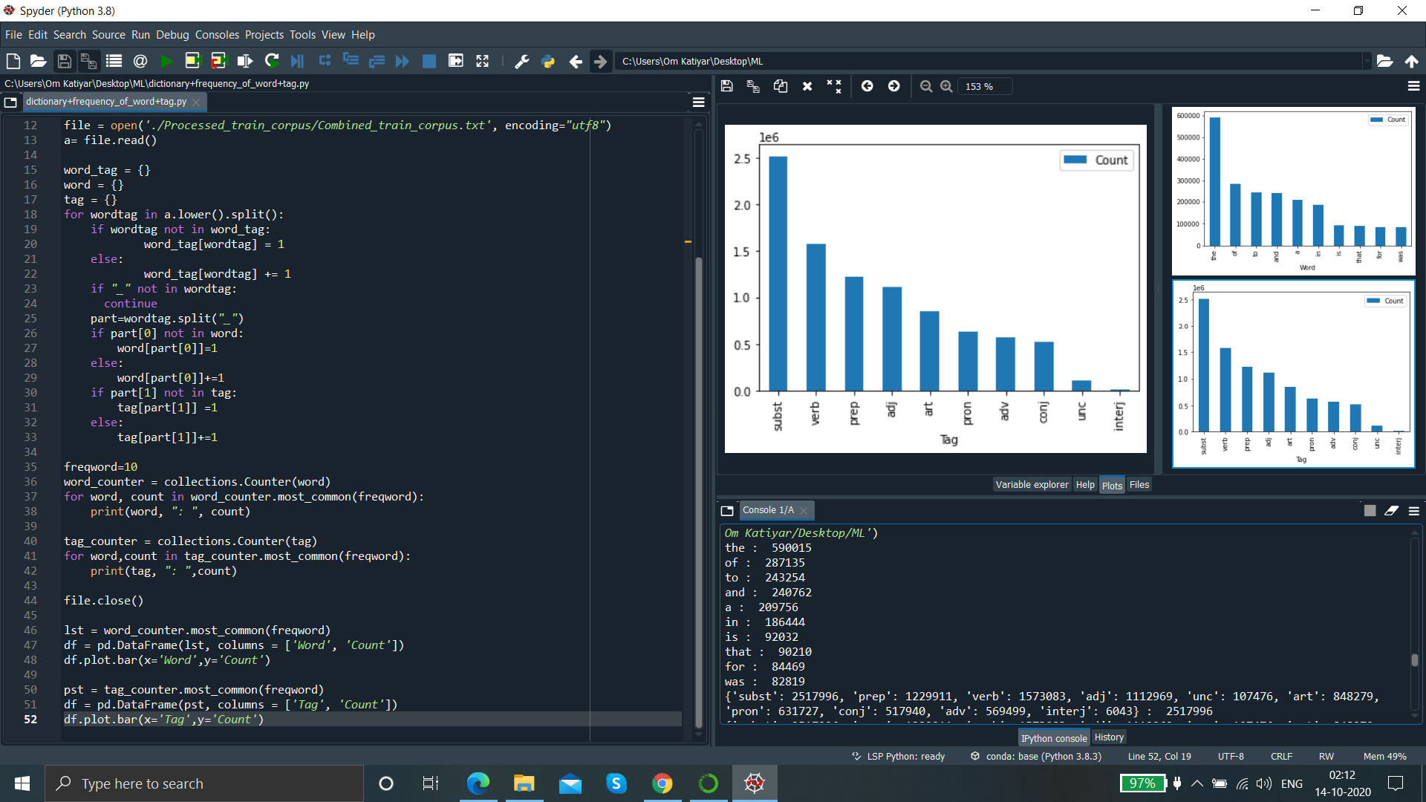

*Screenshot of the code along with output as 10 frequently used word and tags*

TOP 10 used words from train corpus:

WORD : No. of Occurences

the : 590015

of : 287135

to : 243254

and : 240762

a : 209756

in : 186444

is : 92032

that : 90210

for : 84469

was : 82819

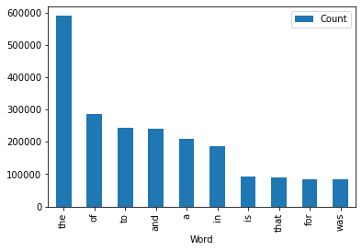

TOP 10 used tags from train corpus:

TAG : No. of occurences

'subst': 2517996

'prep': 1229911

'verb': 1573083

'adj': 1112969

'unc': 107476

'art': 848279

'pron': 631727

'conj': 517940

'adv': 569499

'interj': 6043

